XENA HIGH LEVEL DESIGN DOCUMENT

1. Background 1
2. Scope 2
3. Definitions 2
4. Overview 2
5. Architecture 2
6. Plugin Architecture 4
7. Normalising 4
8. Viewing 8

Background
This document is intended to give a high level overview of the Xena system. Xena exists as either a preservation framework or an API to access existing preservation functionality.

Xena has been built to form part of the solution to the problem of digital preservation. The primary purpose of Xena is twofold. In the first instance, Xena is designed to capture the essence of a given digital object and store it in a self-documenting format. To do this Xena uses XML and the process is known as “normalising” a digital object. The second purpose of Xena is to allow a user to see a performance of the normalised object. To do this, Xena ‘performs’ the normalised object – typically displaying it on the screen – and thus recreates the essence of the original object.

A digital object is usually a file, but also encompasses such things as websites, entries from a database, and items consisting of multiple files. When Xena normalises a digital object, it turns it into a single XML file. In order for this to occur, the data object must be able to accessed as a data stream.

In order to give Xena the ability to normalise and subsequently view a large number of different digital object types, Xena has been designed to use a plugin architecture. Xena loads plugins at runtime, and each plugin consists of a number of discrete classes. The plugin has a preferences file, which defines what functions each of the classes are used for. For example, a plugin may include one or more ‘XenaType’ classes, which describe a type of digital object; a guesser class for each type to ascertain whether a given digital object is an instance of that type; a normaliser for each type; and finally a viewer for each type.

Plugins may also contain classes that allow Xena to specify the output filename for a normalised object and ‘wrap’ the XML produced by normalisation with metadata describing the package.

For the full details of Xena plugins, and their components, please see the Xena Plugin Overview document.

Scope
This document is intended for developers and other interested parties. It forms a technical design document for the Xena object. For the purposes of this document, the Xena GUI is considered as separate to the Xena object.

Definitions
For the purposes of this document, the terms listed in this section are defined to have the meaning that is ascribed to them here.

Normalise – Transform a file from its existing format to XML.
Normaliser – A java object that is a component of a plugin that can transform a file into XML.
Plugin – One or more compiled java classes that may be bundled in a java archive, that can be used by Xena to perform some of the functions required by Xena.

Overview
The Xena application has three primary functions:
- The conversion of files from proprietary or closed formats to XML (normalising);
- The performing of normalised files (viewing); and
- The exporting of normalised files from the Xena XML format to the actual preserved format.

Since it is impossible to know in advance which formats will be required to be preserved or the format which is to be used to preserve them, Xena has been built with a plugin architecture to allow new modules capable of dealing with new formats to be loaded dynamically.

The Xena Plugins allow Xena to identify, normalise and display data objects, as well as generate metadata about the data objects and specify the filename of output files. Plugins are loaded at runtime, either by specifying the name of a module that is already accessible from the class path, or by specifying the location of one or more Java archives. In the latter case, Xena adds the Jar files to the Java class path then finds the Xena components by looking for specific files within the Jar.

Xena has also been architected to be simple to integrate with any Java application that requires preservation services. By using a façade pattern, all the methods that are required for the preservation of digital objects are accessible through an instance of the Xena class. The creation of Xena views is handled by the NormalisedObjectViewFactory class, and access to the underlying classes is possible through the

Architecture
The overall architecture of Xena is shown in Figure 1. The Xena object acts as a façade hiding the complexity of the underlying Xena code from any calling application.

The Xena object instantiates a plugin manager, and this object is responsible for managing the plugins which are then loaded into Xena. Each plugin may have one or more of the following components:
- Xena Type
- Guesser
- Normaliser
- Viewer
- MetaDataWrapper
- FileNamer
- PluginProperty

Xena uses a separate object to manage each component type. When a plugin is loaded, Xena parses a preferences file contained in the plugin, which specifies the component types for the classes contained within the plugin. The plugin manager then passes the name of the class to the appropriate plugin manager, which then loads the plugin.

For example, a typical plugin may consist of the following:
- A class representing a Xena Type for a given file format;
- A class to guess the likelihood that a data object is an instance of this Xena Type;
- A class that knows how to convert an instance of the Xena Type to XML;
- A class that knows how to render the XML produced by the normaliser to a Java Swing component; and
- A number of classes that are used as utility classes in support of the classes listed above.
In this case, the preferences file would list each of the classes (other than the utility classes) next to the name of the component which they implemented, and then when the plugin was loaded, the manager for that component would load the class.

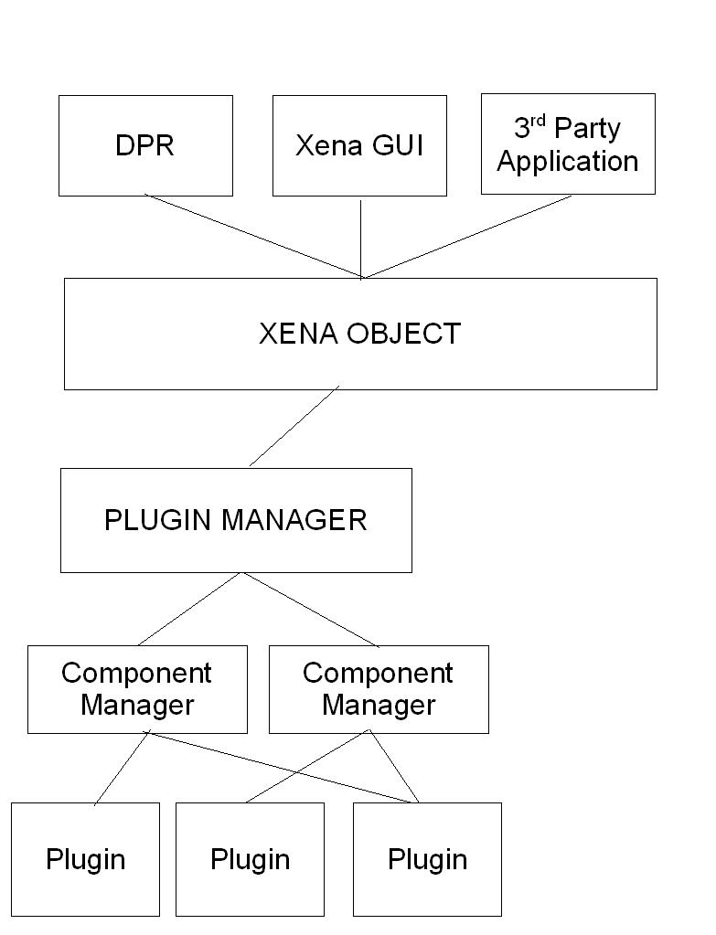
Figure 1 High level architecture of the Xena application.

Normalising
The workflow for normalising a file is shown in figure 2. A short summary of each step will be provided in this section.
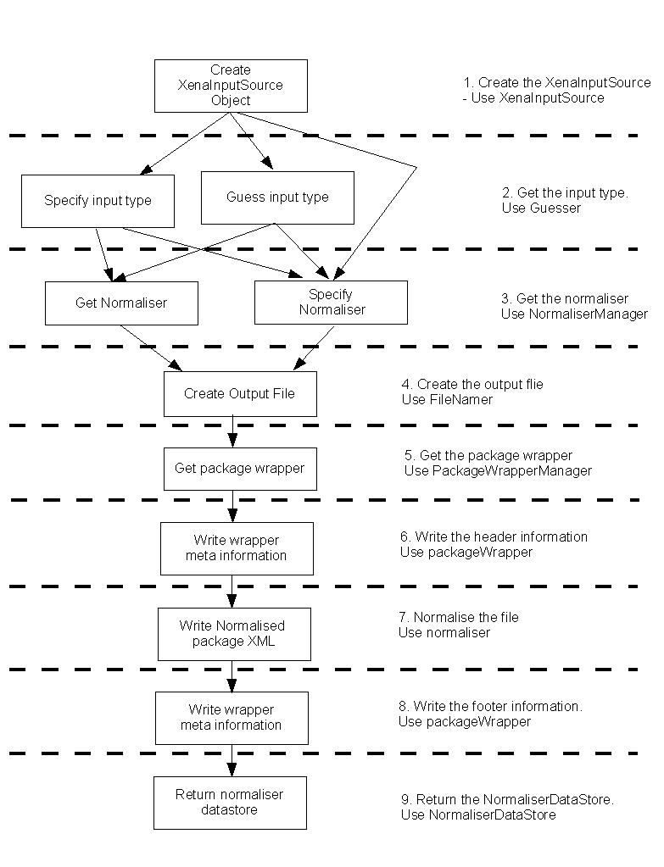
Figure 2 The normalisation process

1. Creation of the XenaInputSource
The XenaInputSource is created from the digital object that is to be normalised. It contains such information as the type of object that it was created from, the URI for that object (i.e.the path for a file, the URL for a web site, etc), and the MIME type of the data contained in the object. It also allows normalisers to get an input stream from the XenaInputSource transparently.

2. Get the InputType
The input type of the XenaInputSource may be guessed by Xena or specified programmatically. If it is guessed, the guesser manager will get each loaded Guesser to create a guess for the object, which consists of the file type and a certainty factor. The certainty is based on the file extension, magic numbers in the file header and data content. The guesser manager will rank the guesses according to certainty, and return the most likely guess. In the case of a tie, guesses are ranked on the order that plugins are loaded. This is not necessarily useful when plugins are loaded from a directory.

The guesser manager can also provide a ranked list of all possible and likely guesses (guessers may return a value of “NOT”. In this case, the guesser manager will not add that guess to the list returned). This is useful if the application requires the user to confirm the guess that Xena has made.

3. Get the normaliser
The normaliser to be used is obtained through the NormaliserManager. There are several ways to select the normaliser to be used. A normaliser can be selected by name, in which case it will attempt to normalise the file as best it can. This is appropriate in a number of cases – most notably that of binary normalising. Alternatively, the normaliser manager can return a list of normalisers that are appropriate for a given type (as returned by the guesser in the previous step, or specified by the application) or the first normaliser it can find for that type. It is possible to influence the normaliser that is returned by changing the order that plugins are loaded.

4. Create the Output File
In this step the output file is created by a FileNamer object. The FileNamer objects are managed by the FileNamerManager object. To create a new file, the FileNamer object must obtain the destination directory for the file, the extension for the file, and whether or not the file should overwrite any previous files of the same name. Finally, the FileNamer may record the generated file name in a history file.

The destination directory for the file may either be specified as an argument to the method to create the new file, otherwise the destination directory is set to the current user directory.

The extension to be used for the new file may also be specified, otherwise a default extension, defined in the FileNamerManager object, is used.

The FileNamer then generates the filename to be used for the file. This is implementation specific – the default file namer in Xena simply appends the name of the normaliser to the filename, the NAA file namer generates a unique string based on the MD5 hash of the file name and the number of seconds since epoch (defined as an arbitrary date sometime before the year 2000). When the name of the output file is generated, the FileNamer checks to see if an output file has been created for the same input source previously. If this is the case, the file namer checks to see if it should overwrite the old file, or generate a new filename. If a new filename is required, the FileNamer must generate a different filename to the previous filename generated.

The FileNamer then checks to see if it should record the new file names to a history file. If this is the case, the FileNamer then appends the input source name and generated output name to a history file (either by opening an existing history file or creating a new history file). It is up to each FileNamer to keep track of the history file.

The output file is then created, and the filename is added to a map that contains each input source, and all the output filenames that have been created for that file.

5. Get the Package Wrapper
The package wrapper is provided by the PackageManager object. The package wrapper is used to ‘wrap’ the XML generated by the normaliser with meta associated with the object. Depending on the requirements of the organisation that wishes to normalise the file, the package wrapper may include such meta data as checksums, the original file name, the file type, and information about the normaliser that was used.

6. Write the header information
The normaliser is an XML filter, and by adding a content handler to the normaliser, then adding the normaliser as a child content handler, the XML can be written in a series of stages. The wrapper is added as a content handler and is the parent to the normaliser, and when the normalisation process begins, the first part of the output XML is generated by the wrapper. The wrapper usually contains meta information pertaining to the data object that is being normalised, but effectively may contain anything. After the header information is written, the output XML looks like the following:
<package>
<meta_information/>
<meta_information/>
</package>

7. Normalise the file
After the initial meta information has been written, the normaliser is called. The normaliser parses the input file and writes out the XML as required. At this stage, the output file is as follows:

<package>
<meta_information/>
<meta_information/>
<content>
<data/>
</content>
</package>

8. Write the footer information
After the normalisation is complete, control is passed back to the wrapper, and it completes writing out the normalised information, and closes all the tags. At this stage, it is possible for the wrapper to analyse the information contained within the XML – for example, to generate a checksum based on the contents of the ‘data’ tag.

<package>
<meta_information/>
<meta_information/>
<content>
<data/>
</content>
<meta_information/>
</package>

9. Return the NormaliserResults object
The NormaliserResults object is created during the normalisation process, and contains a number of fields that represent the result of the normalisation process.

Viewing
The viewing of Xena files, which are produced after normalisation, is comparatively simple. Plugins contain classes to view normalised files that extend the XenaView class. The major components of these classes are a JPanel, a contentHandler, and an XML tag.

In order to display a Xena File, Xena gets the outermost tag, and then finds the viewer that can handle this tag from the ViewerManager. If no viewers can handle the tag, then the Xena file can not be displayed. If a viewer is able to display the file, Xena then creates an instance of this viewer, creates an XML parser and then parses the Xena file using the content handler of the viewer object. This content handler updates the JPanel that is part of the viewer. After this, the JPanel contains a bunch of components that are a representation of the normalised Xena object.

